Updraft 1.0
User's manual
Content
1 Introduction 3
2 System requirements 3
3 Installation 3
3.1 Windows 3
3.2 Mac 3
3.3 Linux 3
4 Application Window 4
5 Map view 5
5.1 Visualization 5
5.2 Camera manipulation 7
5.3 Maps downloading 7
6 Application components 8
7 Airspace database 8
7.1 Importing files 8
7.2 Removing files 8
7.3 Visualization 8
7.4 Hiding airspace 9
8 Turn-points database 9
8.1 Importing files 9
8.2 Removing files 10
8.3 Visualization 10
9 Task Declaration 10
9.1 New Task 11
9.2 Task Drawing 11
9.3 Undoing changes 11
9.4 Task Opening 11
9.5 Task Saving 11
9.6 Task Panel 11
10 IGC Analysis 12
10.1 Igc Opening 12
10.2 Igc Visualization 12
10.3 Igc Panel 13
10.4 Graph statistics 14
11 Settings 15
11.1 General Settings 15
11.2 Map Options (hidden) 16
12 Airspace and turn-points sources 16

Introduction
Updraft 1.0 is a students' software project, developed at the Faculty of Mathematics and Physics at the Charles University in Prague.
The main aim of the project is to create a user-friendly open-source desktop application for glider flight planning and visualization.

The web pages of the project are http://updraft.github.com
Repository with the program's source code is at https://github.com/updraft/updraft

The application is focused on smart flight visualizations, displayed over free yet quality map sources.
It combines single and multiple document application interfaces. Everything can be displayed in one map window at once, but there are panels belonging to each opened file and at a signel moment there is only one “active file”.

System requirements
Updraft is designed as a “multi-platform” application. It runs on Windows, Mac and potentially also on Linux.
For correct application functionality on Windows, it requires Windows 7, Windows Vista, or Windows XP with all available service packs. Graphics is rendered with the OpenGL library, so it is necessary to have the proper OpenGL drivers installed.
On Mac, following OS X versions are supported: Leopard (10.5), Snow Leopard (10.6) and Lion (10.7)
The Linux operating system is basically not supported by our program. However it is possible to run Updraft on Linux without any limitations. As it's not our target platform, it is intended mainly for Linux enthusiasts who are able to compile applications themselves.

Installation
Program installation is platform-dependent.

Windows
A simple wizard will guide you through the installation. You can read the license and change the folder, where the application will be installed.

Mac
For OS X, a compressed disk image (dmg) with an application bundle is prepared. To install the application, open the disk image and drag-drop the Updraft bundle to destination directory (for example Applications folder)

Linux
As was mentioned in previous chapter, Linux is not the primary target platform of our application. There is no installer. However, if all dependencies are met, it is fairly easy to compile the application on Linux using CMake. The source code can be downloaded from our repository.

Application Window
After the start-up sequence is finished, the main application window appears.
It consists of four logical parts:
- Application menu: Provides basic “high-level” functions for file opening/saving, accessing application settings, view manipulation, and opening application help (this manual).
- Map view: Main part of the application window. Contains map and overlaying layers.
- Left pane: Contains tree view with map layers. Allows the user to show or hide them. The left pane can be resized or completely hidden by dragging it's right border (horizontal splitter).
- Bottom pane: This pane adds the multiple document interface to the application. It contains several tabs. Each tab corresponds to an opened file. The bottom pane can be resized or hidden in the same way as the left pane using the vertical splitter.
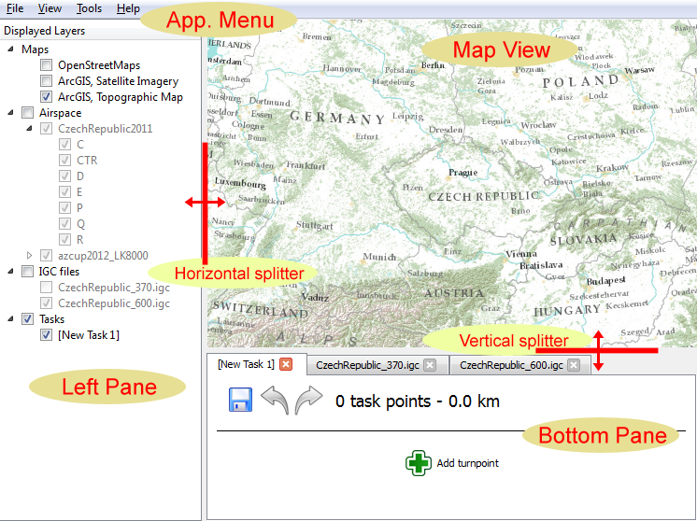Figure 1: Application Window layout

Map view

Visualization
The map is rendered as a 3D textured globe. Any place on the globe can be visualized in detail by zooming to it.
Besides the map itself, map view can display another layers – all rendered at once (turn-points, flight trajectory, airspace division, …)
Which layers are currently displayed can be handled by check boxes in the left pane. On the first start of application, there is only Maps layer.
User can choose from three following maps:
- OpenStreetMaps: This is default map. It's very useful for it's simplicity and cleanness. Only the most important data is drawn, so the map remains readable even with complicated overlaying layers.
- ArcGIS Topographic Map: This map contains much more information than OpenStreetMaps, especially terrain height. The map is also quite clean and suitable for displaying overlays.
- ArcGIS Satellite Imagery: This is not a map, but photo set rendered on the ground. It is intended especially for 3D visualization of recorded flight. Impression of flying in mountains is amplified by rendering of terrain elevation.

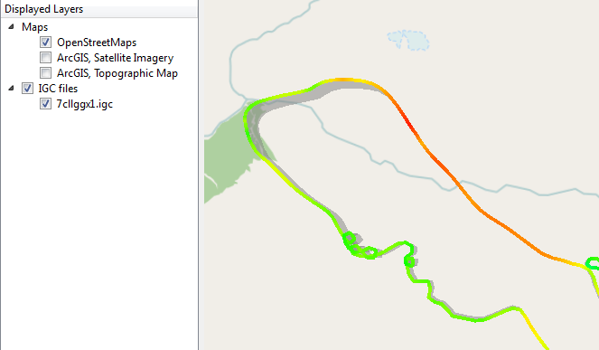
Figure 2: Flight trajectory drawn on OpenStreetMaps
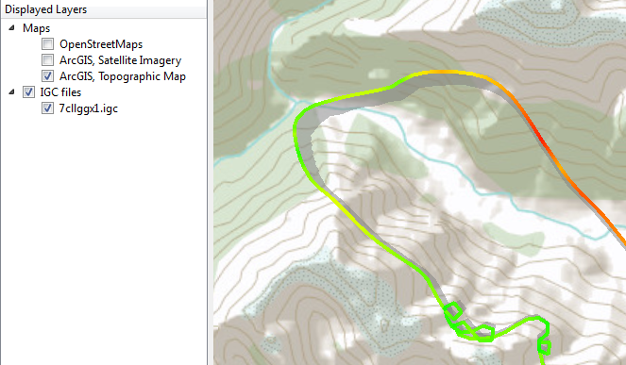
Figure 3: Flight trajectory drawn on ArcGIS Topographic Map

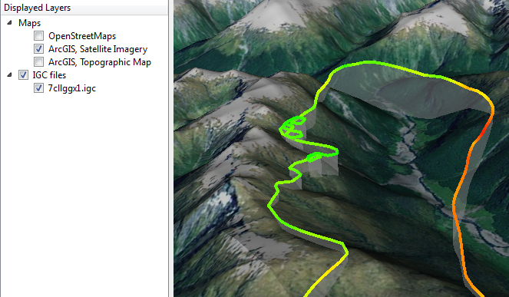
Figure 4: Flight trajectory drawn on ArcGIS Satellite Imagery with terrain elevation

Camera manipulation
In computer graphics, projection of 3D view is often called camera view. To alternate the view, you can move and rotate the camera.
In Updraft application there are many ways to manipulate the camera. User can perform following interactions:
Interaction | Basic control | Alternative controls
Pan | Drag map with pressed left mouse button | Arrow keys
Continuous Pan | Press left+right buttons and drag mouse
Zoom | Scroll mouse wheel | Shift+up/down arrow keys  A,Z keys
Continuous Zoom | Press middle mouse button and drag mouse up/down
Zoom to/from target | Double left click to zoom in  Double right click to zoom out
Rotate | Press right button and move mouse left/right | Shift+mouse wheel  Ctrl+left/right arrow keys
Tilt | Press right button and move mouse up/down | Ctrl³+mouse wheel  Ctrl³+up/down arrow keys
Restore home position | Spacebar

One button mouse alternatives:
Ctrl³+left button is alternative for right button.
Alt+left button is alternative for middle button.
Shift+left button is alternative for pressing both buttons at once.

If you lost yourself in 3D by performing some manipulations, you can easily “normalize” camera position. By selecting “Restore 2D View” in View menu you get back to 2D (nadir) position. You can also align view to north by selecting “Rotate to north” in View menu.

Maps downloading
If you are connected to Internet, maps are downloaded automatically as you move over the globe. When you disconnects from the network, maps are loaded from cache which was created (during downloading) in Updraft data directory.
If you was never connected to internet, you can display only very rough maps distributed with application installation package.

Application components
Beside map viewing, application is equipped with several plug-ins which allow perform task planning operations and flight analyzes.
There are four plug-ins:
- Airspace database
- Turn-points database
- Task declaration
- Igc analysis
All plug-ins are loaded automatically during application start-up.

Airspace database
Application provides visualization of airspace division. It is useful especially for flight planning when pilot wants to avoid prohibited areas.

Importing files
Airspace data is loaded from external files. OpenAir file format is supported.
To get new airspace files, see chapter Airspace and turn-points sources.
To import new file into application, select Open from application menu.
When Open dialog appears, select a file with airspace and click Open. OpenAir file format has extension txt.
When you click open, file is imported to the application. It means that selected file is copied into Data directory.
All airspace files, stored in the Data directory, are automatically loaded during application start up. Loaded files are listed in the left pane in the Airspace group.

Removing files
To remove airspace file, press right mouse button on the associated item in the left pane and choose remove.
You can also remove file directly from the Data directory, using your favorite file browser. However this action become evident first in next application run.

Visualization
Elementary parts of the airspace are specified as a 3D geometric primitives. They are described by horizontal edges, consisting of lines and arches, and top and bottom caps.
In map window, there are shown semi transparent side faces. Used color is specified in the airspace file. When the 2D view is active, only line boundaries are visible.

Hiding airspace
Each loaded airspace file has associated item in the left pane and also sub items for every contained airspace class. Naming of the items depends on naming used in the file. Each particular class can be individually displayed/hidden by pressing the check-box beside it's label in tree. You can also show/hide whole file or even all airspace files by pressing check-box beside appropriate labels.
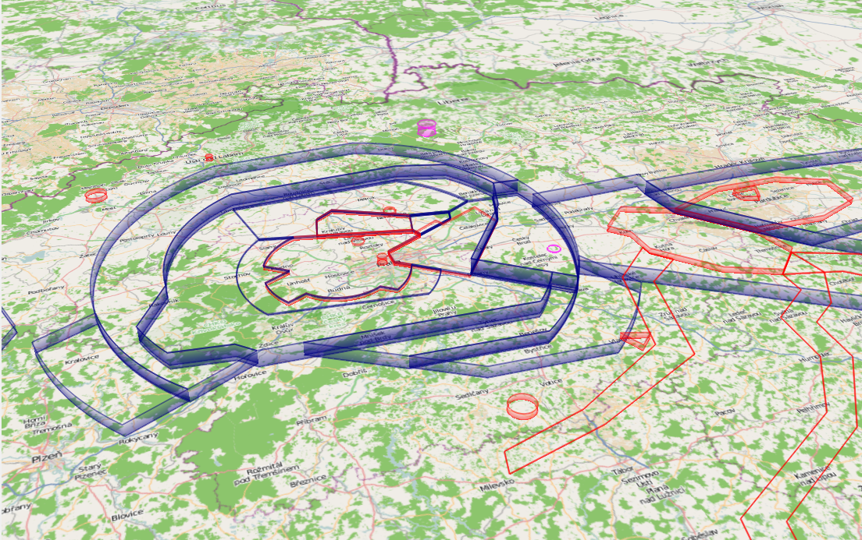
Figure 5: Airspace division visualization. (Prague, Caslav and Pardubice (M)CTRs, (M)TMAs)

Turn-points database
If the pilot declares a task in his on-board device, he chooses a few turn-points from a file stored in this device.
These files are usually published by some authority in the region, by the jury of a competition or e.g. by some enthusiast in the air club.
Updraft application gives you opportunity to use such files for planning tasks on the PC.

Importing files
You can import predeclared turn-point sets and display them in the map.
To get new turn-points files see chapter Airspace and turn-points sources.
SeeYou *.cup files are supported.
To import new file into application, select Open from application menu.
When Open dialog appears, select a *.cup file with turn-points and click Open.
When you click open, file is imported to the application. It means that selected file is copied into Data directory.
All turn-points files, stored in the Data directory, are automatically loaded during application start up. Loaded files are listed in the left pane in the Turn-points group.

Removing files
To remove turn-point file, press right mouse button on the associated item in the left pane and choose Delete from context menu.
You can also remove file directly from the Data directory, using your favorite file browser. However this action become evident first in next application run.

Visualization
Turn-point can be either airfield or general turn-point. The type is read from file. If it is airfield, it is provided by runway direction.
General turn-point is visualized as a blue disk on the ground, airfield is displayed as a blue circle, crossed by thick line in runway direction.
Depending on camera distance there are displayed labels with turn-point names.
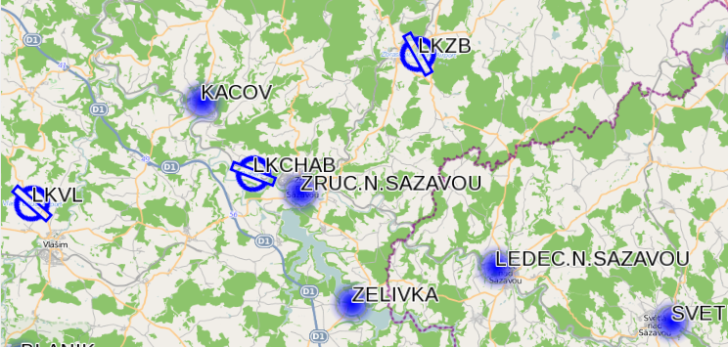
Figure 6: Turn-points visualization. Airfields have icon with runway direction.

Task Declaration
This module helps user to declare a task. Task consist of a few points which pilot should reach during his flight. Declaring goal in advance and trying to reach it is the basis of glider cross country flying. There are many circumstances which must be considered in flight planning.
Namely weather conditions, active airspaces (e.g. military), pilot experience, glider performance, etc. According to these circumstances pilot declares a task. Basic parameters of the task are distance and shape. It is easier to achieve goal when you flies from home airfield to one near turn-point four times back and forth than situation when you flies a triangle of the same length.
Plugin Task Declaration allows drawing any polygonal task and computes total distance, length of each leg and it's azimuth. It is also able to detect FAI triangle (according to the FAI sporing code).

New Task
To create an empty task, select New Task item from application menu. New task panel appears in the bottom pane.

Task Drawing
For adding a new task-point, click on the “Add turnpoint” button in the task panel. Now the button is pressed/checked and task-point will be added when you click on the map.
Add button remains pressed until you uncheck it. Till then you can append any number of points to the end of task.
If you click near a predeclared turn-point, the task-point is snapped to it. When this happens, new task-point widget, labeled with the name of the turn-point, appears in the task panel. If you pick arbitrary map point (not a turn-point), label contains geographical coordinates instead.
Inserting points in the middle of a track is possible after clicking “+” button between desired task-points.

Undoing changes
All changes done to the task are logged and can be rewound. For undo/redo actions there are two buttons with arrows in the task panel.
Note: If you press undo and then make any change to the task, then it is impossible to perform redo.

Task Opening
You can open previously declared task by selecting “Open...” item from application menu. Tasks are stored in xml formatted text files and have “tsk” extension. To open more task at once, select more files with pressed Ctrl or select a range with Shift.

Task Saving
Task can be stored in file system. To do this press save icon with diskette or select “Save” or “Save as...” from application menu. On the first saving always appears Save dialog. If the file has been already saved, Save dialog appears only when you select “Save as...” from menu, otherwise file is stored to its original location.

Task Panel
Each opened task has assigned panel in bottom pane. Beside fore-mentioned buttons for saving, undo/redo and adding new points, there are two text fields containing task parameters.
First text field (right to the undo/redo buttons) contains task shape, official and total distance.
Task shape can be either: Out and return, Triangle, FAI Triangle, N-points task, N-points closed task.
Total distance (written in round brackets) is sum of all tasks legs lengths. It is counted on the ellipsoid model, which is by default WGS84.
Official distance is total distance subtracted by 1km for each middle task-point and 0,5km for the first and last task-point. (This is because, according to FAI rules for usual tasks, there is 500m tolerance for reaching each task-point.)
Second text field contains lengths and azimuths of each legs. Label of each leg is decorated by arrows pointing to surrounding task-points.
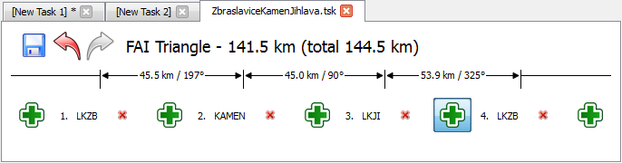
Figure 7: Task declaration panel. Green “+” buttons allows inserting new task-points at any point of task. Red “x” buttons delete corresponding task-points.

IGC Analysis
Updraft application contains Igc Viewer plug-in, which is designed to analyze flight log.
For better understanding, now follows brief description of the procedure, how the log is recorded.
Flight log is made by on-board device called flight recorder or logger. This instrument is equipped with GPS receiver and also barometric altimeter. It makes records in regular intervals (e.g. once per 10 seconds) and stores them in the inner memory. These records are called fixes. Each fix can contain GPS coordinates and barometric height. After landing, flight is saved into one file with extension igc. Some loggers have memory card, which can be removed and used for uploading to computer. Some loggers have serial interface for connecting to computer and downloading igc files.
Updraft Igc viewer is able to load and visualize such igc files.

Igc Opening
One or multiple igcs can be opened and inspected at once. For loading igc file, select Open item from application menu.

Igc Visualization
Flight is rendered in map view. It looks like a thick colored polygonal line. The line is drawn in 3D, so it hangs above the terrain. For better “binding” of route to the terrain, there is drawn semitransparent curtain under the line, which connects it with the ground, so the exact flight path can be inspected.
If multiple flights are displayed, then each has it's own color. Tracjectory coloring can visualize also dynamic values computed for every single fix (e.g. ground speed). All possible values are listed in chapter Igc Panel.
Values are visualized as rainbow colors. Blue color corresponds to the lowest values (e.g. lowest speed) and red color corresponds to the highest values. If multiple flights are opened, then they share the coloring and also it's scale.
It means that red parts of any displayed trajectory correspond to the highest values among all igcs.
Coloring according to the vertical speed is specific, because it can be also positive and negative. Zero vertical speed is always rendered with green color.
Each trajectory can be hidden/shown by clicking appropriate check-box in the left pane.
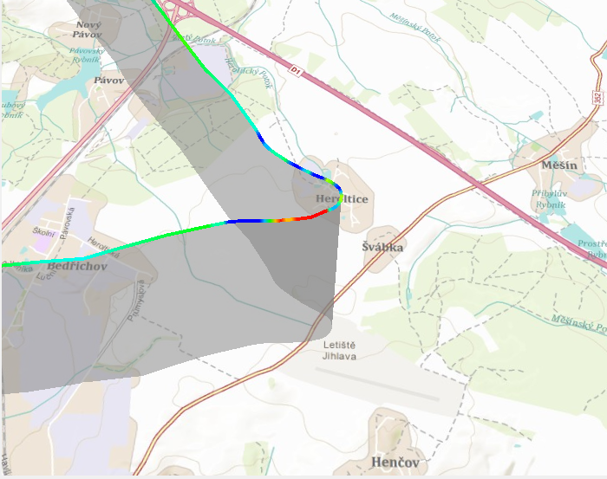
Figure 8: Igc curtain connecting flight trajectory with the ground. Trajectory is colored by vertical speed. Green parts – constant height, red parts – climbing, blue parts – sinking.

Igc Panel
Bottom pane contains tab for each opened igc file. It consists of three graphs combobox for selecting trajectory coloring and also auxiliary statistics window. Graphs share time (horizontal) axis. First graph shows altitude in meters, the second one shows ground speed (km/h) and the third one shows vertical speed (m/s).
For better graph inspection it is possible to enlarge it by dragging upper border of bottom panel.
Trajectory coloring mentioned in chapter Igc Visualizaion can be changed with combobox to one of the following values:
- Automatic: Default value. Assign each igc file one color. In fact there are only seven colors available. If more igcs are opened, they get again the same colors.
- Altitude
- Ground Speed
- Vertical Speed
- Time: Flight begin is colored with blue color, flight end is colored with red color.

Graph statistics
Igc graph can be enriched with simple statistics. They are shown in the graph auxiliary window and some of them also directly in graph. Statistics are computed for arbitrary point in the graph and also for intermediate segments (defined by two neighboring points).
User can add new point to the graph by clicking on it. The point is represented by gray vertical line shared among all graphs. Small icon is also drawn in map view to appropriate part of visualized trajectory.
By right clicking on the graph all added points are removed.
Inserting of points is also possible by clicking directly to trajectory in map view.
For each point are printed out actual values of graphs (altitude, GS, VS) and also time (UTC). For intermediate segments are computed following values:
- dT: Time difference between surrounding points.
- dS: Direct distance between points (in km, computed on the ellipsoid surface)
- dH: Gained height (altitude difference in meters)
- GS: Average ground speed = dS/dT (km/h)
- VS: Average vertical speed = dH/dT (m/s)
If there is enough space, segment statistics are drawn under the graph.
All statistics are printed out in the fore mentioned small text window beside the graph.
First and last fix of igc form implicit graph points. So if user places one point into the middle of graph, trajectory is automatically divided into two segments.
By moving mouse around the graph, there is shown temporary gray line for the point under the mouse and it's statistics are printed in the upper part of text window. Mark for this point is also rendered in map view.
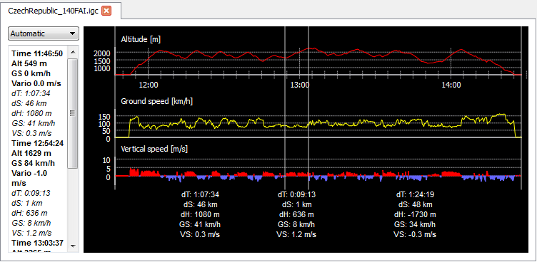
Figure 9: Igc graph with statistics for three segments. Left to the graph is text window containing statistics for all marked points and intermediate segments. Dropdown (combobox) above the text window serves for igc trajectory coloring selection.

Settings
Through application menu is accessible Options dialog, where user can change some application variables. There are two settings level: basic and advanced.
Advanced settings are intended for more skilled users. They are displayed by switching on „Advanced settings“ check-box.
Some settings changes will be made after application restarts. These are marked with “*”.
If you make some changes and wants to undo them, click “Reset: button.
If you want to restore original values of all settings, press “Restore Defaults”

General Settings
- Language: Changes language localization of the Application. English (default) and Czech localizations are supported.
- Data directory: Selects directory where will be stored Updraft data. Application stores map cache in this directory, imported files (turn-points and airspace files) and also some pre-installed data files (icons etc.)
- Ellipsoid model: Selects ellipsoid model of Earth for distance computing. Supported options are WGS84 and FAI Sphere. This selection affects all measurements (igc statistics and task declaration).

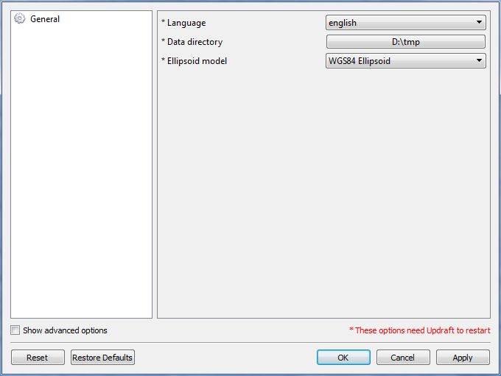
Figure 10: Settings dialog

Map Options (hidden)
- Mouse zoom sensitivity: Adjusts speed of zooming with mouse scroll.
- Mouse click tolerance: Adjusts delay between mouse button press and release. If this value is large, even long holding of mouse button will be accounted as a single click.

Airspace and turn-points sources
Turn-points and airspace files can be taken from various locations, there is a list of some basic Internet sources:
- http://soaringweb.org/Airspace Web for free airspace data exchange
- http://soaringweb.org/TP/HomePage.html Web for free turn-points exchange
- http://www.lkka.cz/sport/files/Points.zip Actual set of Czech turn-point published by Czech glider committee.
- http://gliding.cz Page containing links to webs of Czech glider competitions. From such webs can be downloaded both turn-points and airspace files intended for that competition.

Link to git repository web front-end: https://github.com/updraft/updraft
Map rendering and manipulation is performed by osgEarth toolkit. For more information about osgEarth visit http://osgearth.org
On Mac computer is used Command key instead of Ctrl.
This is intended for one button mouse which are common for Macs.

